2020 Spring Speaker Series

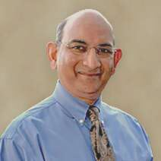
Date: April 14, 2020

Speaker: Dr. Rakesh Bhargava

Background: Director, Heart Care, Oshawa

Title: Advances in Treatment of Heart Diseases: A 40 Year Journey

Description: Learn about the latest advances in treatment of heart attacks, cholesterol, heart failure, cardiac arrhythmias and heart valve replacements without open heart surgery. This will be an interactive discussion with DR. Bhargava, Cardiologist

Link to more information:

https://heartcarecanada.com/team/dr-rakesh-bhargava/
https://heartcarecanada.com/

